16.47: a) Mathematically, the waves given by Eq. (16.1) and Eq. (16.4) are out of phase. Physically, at a displacement node, the air is most compressed or rarefied on either side of the node, and the pressure gradient is zero. Thus, displacement nodes are pressure antinodes. b) (This is the same as Fig. (16.3).) The solid curve is the pressure and the dashed curve is the displacement.

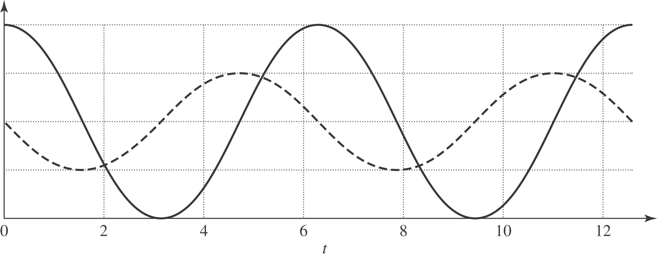

c)
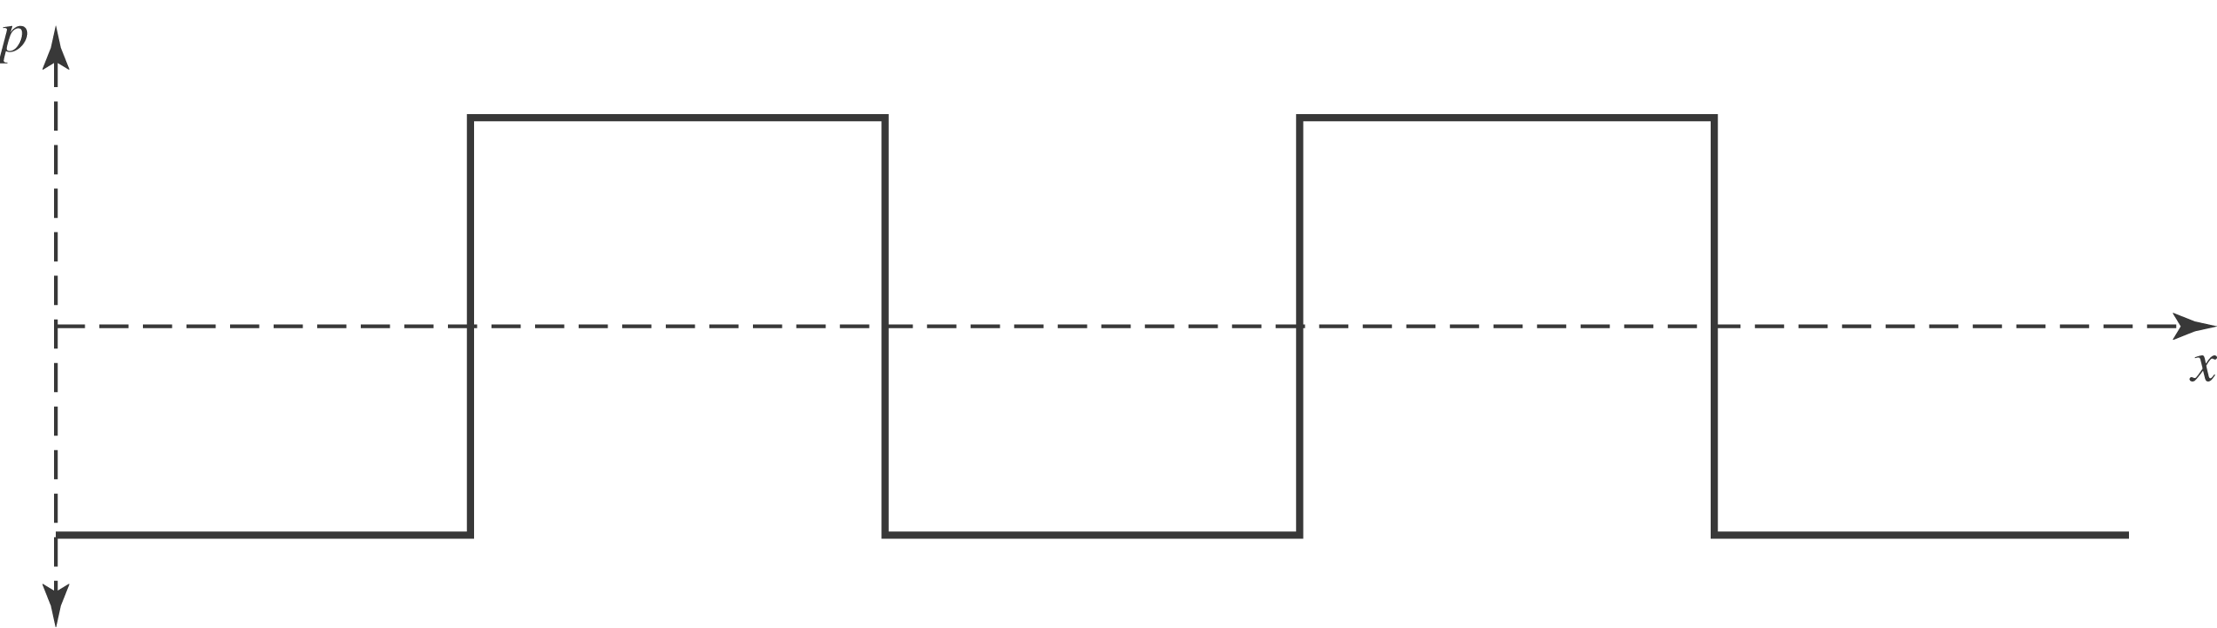

The pressure amplitude is not the same. The pressure gradient is either zero or undefined. At the places where the pressure gradient is undefined mathematically (the “cusps” of the 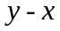plot), the particles go from moving at uniform speed in one direction to moving at the same speed in the other direction. In the limit that Fig. (16.43) is an accurate depiction, this would happen in a vanishing small time, hence requiring a very large force, which would result from a very large pressure gradient. d) The statement is true, but incomplete. The pressure is indeed greatest where the displacement is zero, but the pressure is equal to its largest value at points other than those where the displacement is zero.

